**Use SQL 5**

Write queries (a) to (d) based on the tables **EMPLOYEE** and **DEPARTMENT** given below:

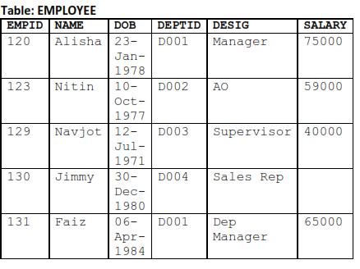

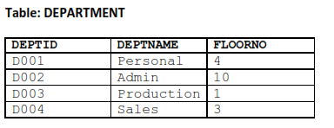

1. Create a Employee table with the attributes where the Empid is the primary key, and Department table with attributes where the DEPTID is the primary key.
2. Insert the details with the above tables.
3. To display the average salary of all employees, department wise.

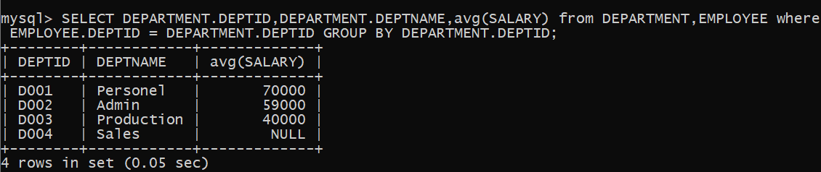

1. To display name and respective department name of each employee whose salary is more than 50000.

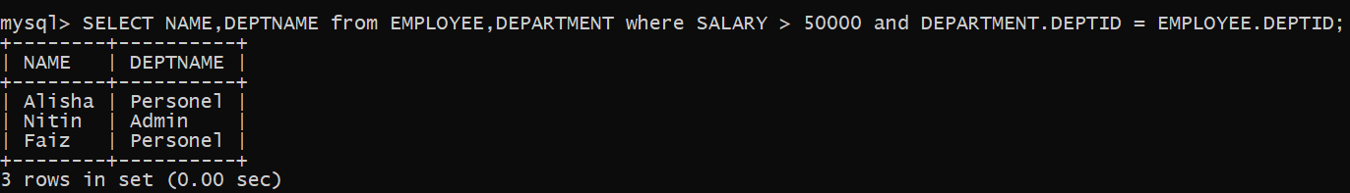

1. To display the names of employees whose salary is not known, in alphabetical order.

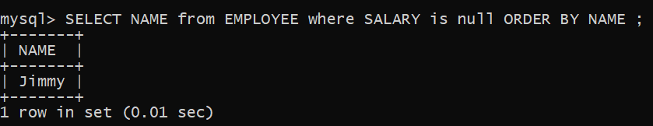

1. To display DEPTID from the table **EMPLOYEE** without repetition.

